University of Kent
May/June 2021

Examination Answer Booklet
Before starting this examination, you MUST enter your Examination Number above (double click); failure to provide this means your mark cannot be recorded and you may be awarded a 0 (zero) for this examination.
Re-save the answer booklet to include your exam number in the file name, using the following format: [your exam number] [module code] AnswerBooklet (e.g. 123456 XX123 AnswerBooklet).
Answer one question per page. You may add additional pages to this document if necessary.

Question Number | 1
Add your answer below:

a)
- Changing the reference of V_{m}(t+1) to V_{m}(t) would cause the previous membrane potential to update, instead of creating a new membrane potential.

- Increasing the number of ions in g_bar_i by double would make it harder to excite the neurons, as it causes a stronger inhibition of the membrane.

- Decreasing the number of ions in g_bar_l by half would make it pass less ions, as it causes a slower decay potential for excited neurons.

- Removing V_{m}(t) would move it from 0 to -70mV, as it makes V_{m}(t+1) to only use the rest of the equation.

- Doubling the value of dt_{vm} would increase the change rate of V_{m}.

b)
Exciting an already excited neuron is not possible would not go higher than its value, as it is already near +55mV. Due to it being close to this value, it would instead cause inhibition and leak to drive the neuron nearer to -70mV.
Exciting an inhibited neuron would increase the value substantially, as it is already near -70mV. As the neuron is not near the excitation threshold, therefore driving the membrane potential closer to being excited.
c)
The resting potential of leak and inhibition potential would always be in the negative state, meaning it would have the value of -70mV. If it is lower than this value, the equation for V_{m} will switch around. Meaning that the neuron will start going towards the positive state, which is +55mV.
d)

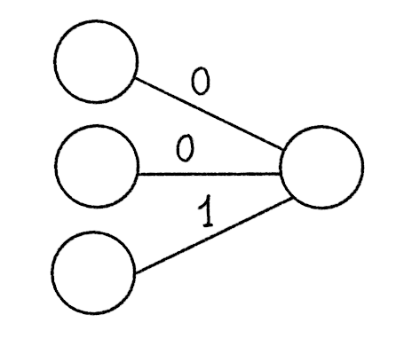

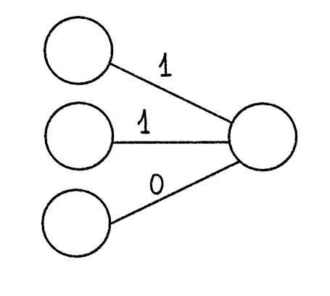
e)
All of g_bar_i, g_bar_l and g_bar_e will be doubled in value.

Question Number | 3
Add your answer below:
a)
- High value: [1, 0, -1, 0]
Low value: [0, 0, 0, 0]

- This helps with the correlation between inputs.
b)
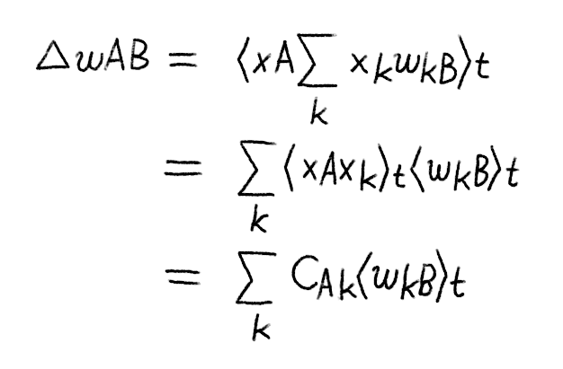
The reason I did this formula is to calculate the weights dominated with the strongest component of matrix C, essentially calculating correlation across all patterns.
c)
- SSE measures the correctness of the model output by looking at what is in the input. What is inside the brackets is the error. The purpose of T_{k} is the value we want and o_{k} is the weighted input. The purpose of the square is to make the derivative easier to calculate and reduce the difference of the sign.

- The delta rule is there to update the weights, which lead from the input layer to the output layer. The delta rule is derived from obtaining a derivative from SSE.
d)
[0,0] -> [0]
[0,1] -> [1]
[1,0] -> [1]
[1,1] -> [0]

Question Number | 4
Add your answer below:
a)
The biases are trained to correct constant errors by the unit, and if a unit is too active/inactive then the biases will correspond to said unit to correct the error.
b)
- The presynaptic symbol is: s_{i}
The postsynaptic symbol is: o_{k}

- The difference between t_{k} and o_{k} is the error, which is why the teacher signal and error relate.

- This is not a sensible learning rule, because the weight calculation will all be the same if S_{i} was to be removed, meaning that all the weight inputs will be the same values. Swapping O_{k} and T_{k} does not matter, because it gets squared. So, if it is a negative value, it would be squared.
c)
- Random initialisation is necessary because it helps reduce biases, which are caused by weights that have values that are initialized way too high/low.

- To compensate, the initialisation of the weights can be done close to the value of 0.5, which is the neutral state of weights.
d)
Using rectified linear units, compared to sigmoidal activations, has the advantage of faster and effecting training of complex datasets. This is due to the linearity that allows gradients flow efficiently on neuron paths.

